|  |
| --- |
| **Name Ahmed Ebrahim Essa Ebrahim Metwally Emam** |
| **EDU Email: Ahmed195020@feng.bu.edu.eg** |
| **B.N: 19** |
| **Topic: Big Data** |
| **Subject Code: ECE001** |

|  |
| --- |
| **A link to my project**  [**https://github.com/Ahmad-Ebrahim/ece001**](https://github.com/Ahmad-Ebrahim/ece001) |

**At first we need to know what the data is, first before we know what the big data is?**

**Data: is the raw image of information until it is sorted, organized and analyzed and can’t be used in this way until processing it. Such raw data are therefore divided into three types:**

**Structured data: These are tables or system rules structured data.**

**Unstructured data: it is the largest amount of data, and it is the data that people produce on a regular basis from text writings, photographs, images, tweets, website clicks and other data.**

**Semi-structured data: Type of structured data is considered, but the data is not in the form of tables or databases.**

**What big data are after we know what the data and its forms are now?**

**Experts describe it as any collection of data that is greater than the ability to process it using conventional database methods such as collecting, exchanging, uploading and handling an analysis within an appropriate time frame for that data, which from the point of view of service providers, are the resources which processes that companies use to deal with large volumes of data for analysis purposes. The two parties have decided that, in the light of these limitations, these are massive data that can’t be handled in the conventional way. Some organizations vary in their concept of big data, like Gartner, a company that specializes in research and information technology consulting, which defines evidence as massive, fast-flowing and very diverse information properties. To develop insights and decision-making methods, that requires economically feasible and innovative treatment methods. Another example such as (IBM) 'an organization that generates big data through all around us and every time every digital process and every social media interaction produce us big data, transmitted through systems, sensors and mobile devices Big data has numerous sources in terms of speed, size and diversity. As far as the International Organization (ISO) is concerned, it describes it as "a group or groups of data with specific characteristics (such as size, speed, diversity, variance, data validity... and other characteristics) that cannot be handled effectively Using current and conventional technology to benefit from it."**

## **Some application on Big Data:**

# **In education:**

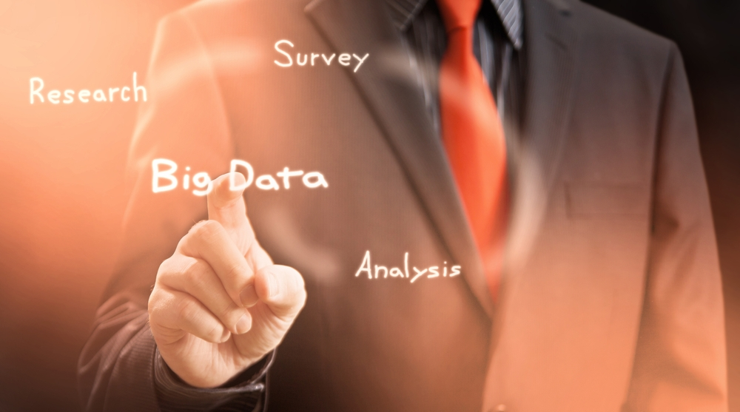**Big data analysis can benefit from learners' data, their learning experiences, social interactions in learning environments, learning activities such as texts, videos, and media in designing customized learning environments according to specific needs of students, as well as improving student learning through qualitative learning or competency-based education.**

Figure 1

# In the economic field:

**Companies, institutions and bodies can now analyze the movement of customers from buying and selling accurately so that they can know the most requested goods and suggest specific goods to their customers according to the purchases that are made since the figure (2) next door shows the use of big data in marketing, as well as it analyzes the data of users of social networks or email through their preferences and preferences to use them in marketing to bring in the best profit for the 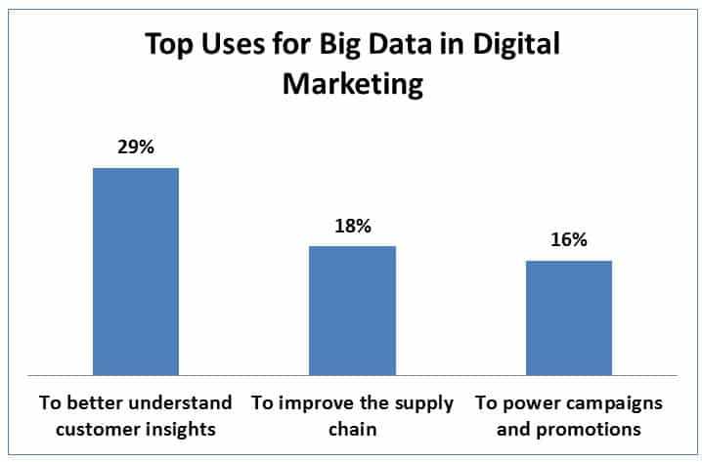company.**

Figure 2

# In the medical field:

**Governmental hospitals, doctors and medical centers can now take advantage of the big data to study the behavior of patients by analyzing their medical files, the visits they made and the wearable technologies, in addition to reducing the waiting time in the emergency departments, and we also use the big data in the pharmaceutical industry, distribution and pricing, and thus increase sales in areas Specific.**

**The graph in Figure 3 illustrates the increase in health care from 2013 to 2020**

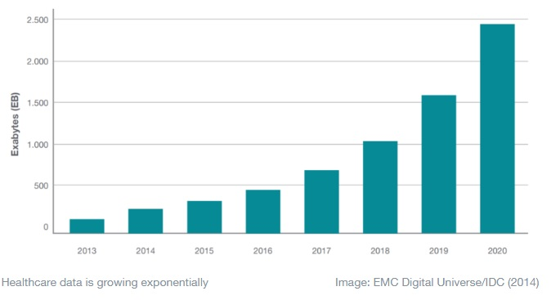

Figure 3

# In the government sector:

**Most governmental organizations possess huge amounts of data stored in computer systems, most of which are not structured. In order to understand the patterns in this data, these governmental organizations must apply statistical models to capture and process huge amounts of unstructured data and this process is called big data.**

# In the military field:

**The amount of big data increased in the military field, where many smart things were manufactured, including weapons, as the fields of fighting terrorism and network security contributed to the growth of data related to the military field that is also generated by many military operations, and the analysis of this data helps in strengthening and maintaining national security, and analyzes the behavior of The military after collecting their data, and fighting terrorism.**

**Therefore, big data has been used in some applications, including WhatsApp, more than one billion users, and more than 42 billion messages and about 1.6 billion pictures are circulated daily. Facebook deals with more than 50 billion photos of its users. Google deals with about 100 billion searches per month.**

# **Screenshot from my website I hope you like it:**

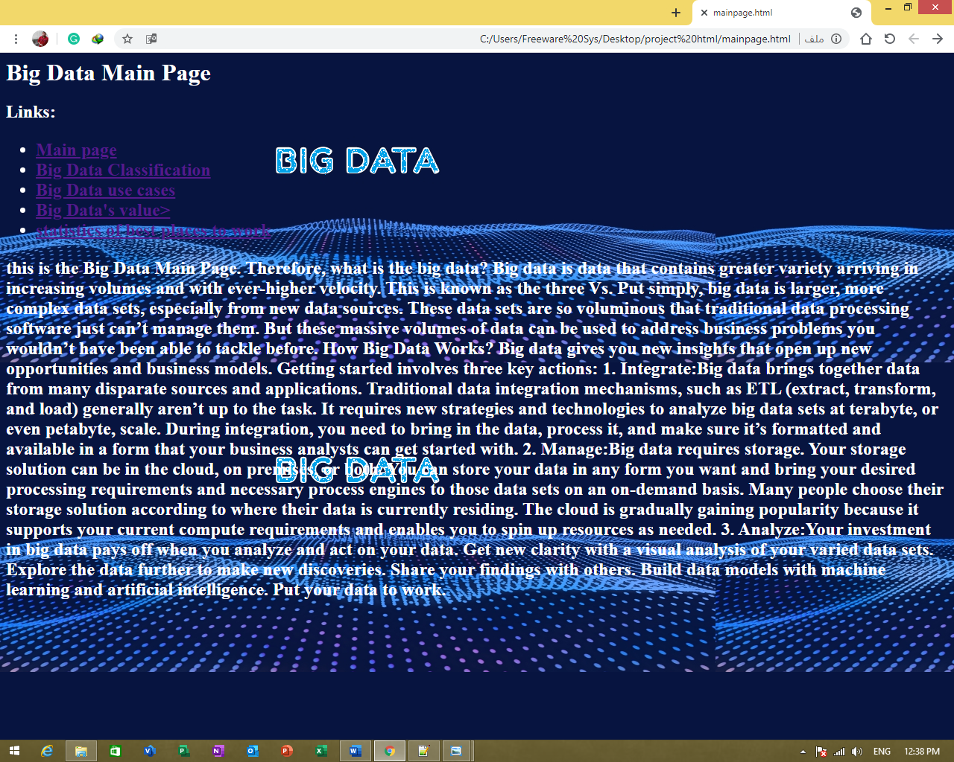

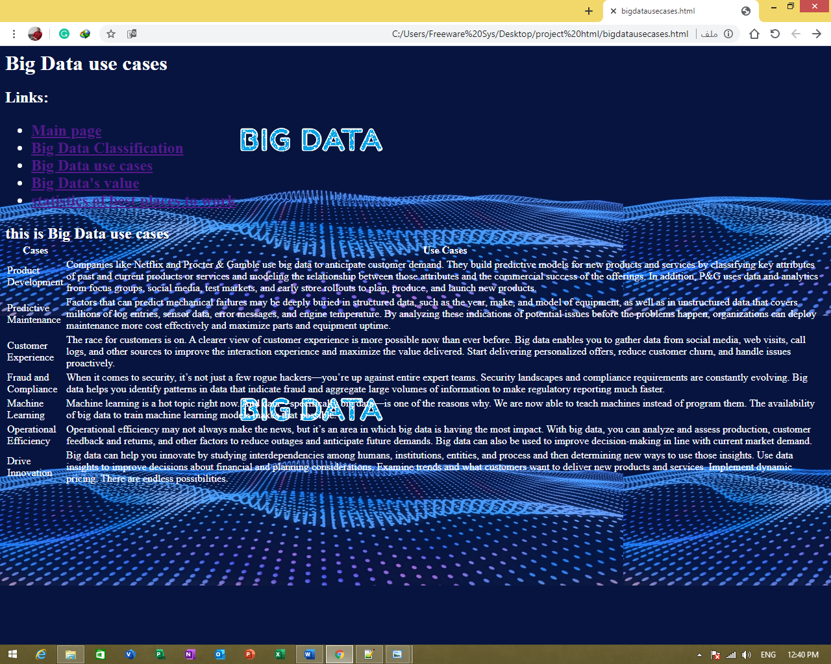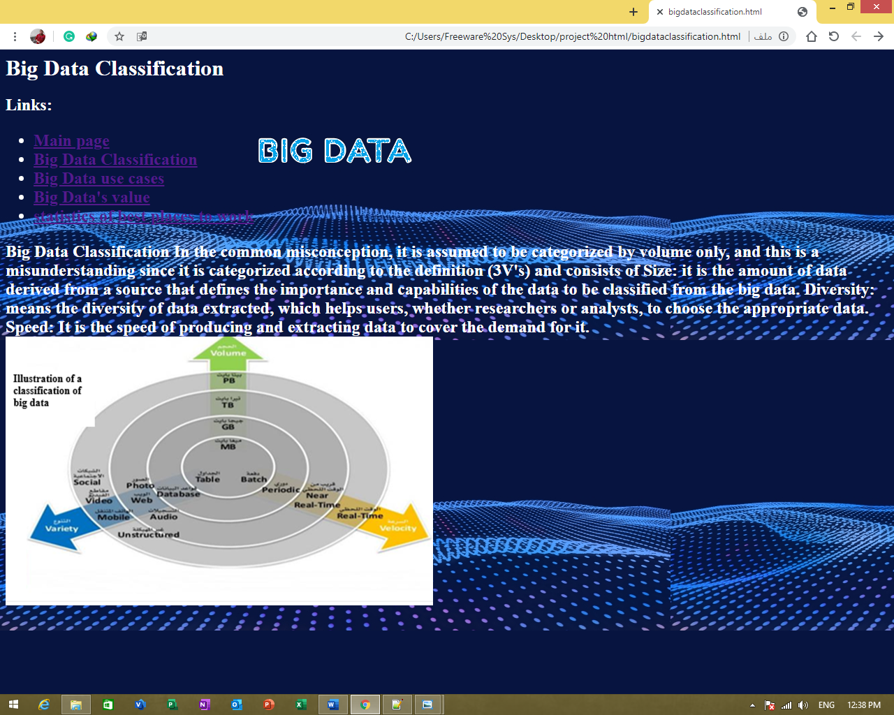

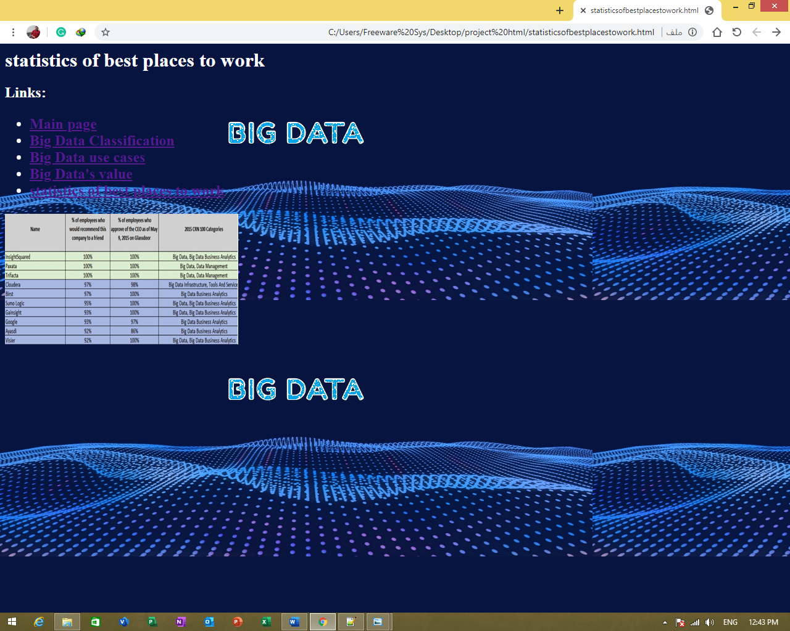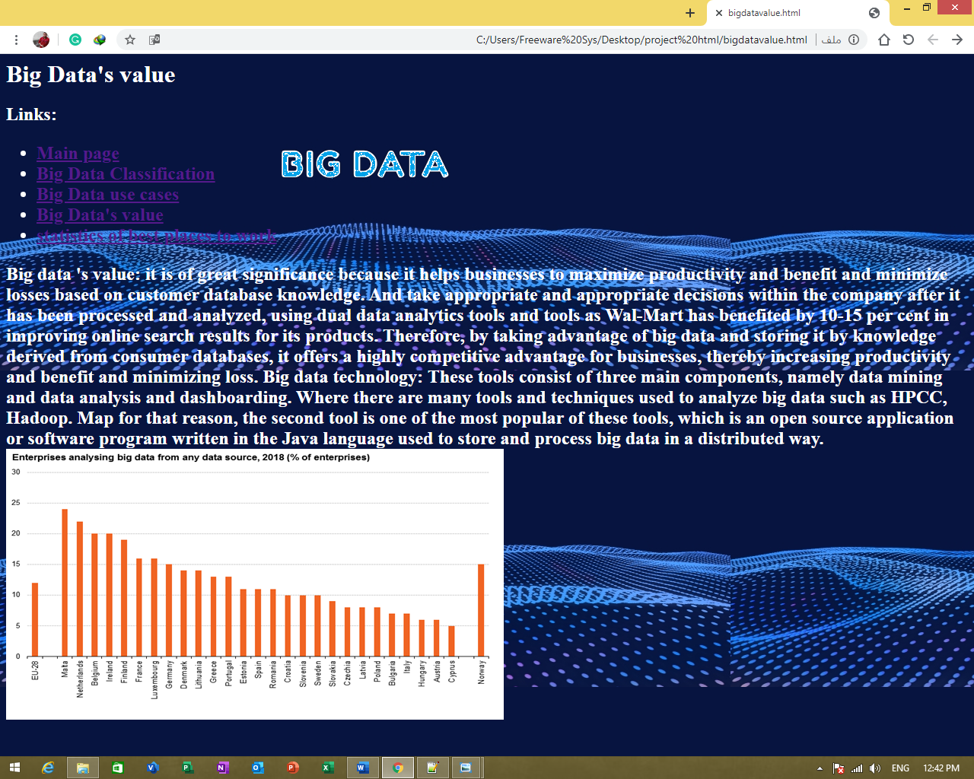

# **Source Code from my pages I hope you like it:**

